**Task 9**

**Computer Networks (Lab)**



**Submitted to Mr. Rasikh Ali  
Submitted by M.Naqeeb**

**Roll #: SU92-BSSEM-F22-100  
Section: SE-5B**

**Submitted on Dec 09, 2024**

**DEPARTMENT OF SOFTWARE ENGINEERING  
SUPERIOR UNIVERSITY, LAHORE**

Contents

Difference Between Sub-netting and Super-netting 3

Sub-netting 3

Example 3

Super-netting 3

Example 3

Direct Comparison 4

# Difference Between Sub-netting and Super-netting

## Sub-netting

Subnetting is the process of dividing a larger network into smaller, more manageable sub-networks (subnets). It is typically used to improve network performance, security, and address allocation within an organization by breaking down a large network into smaller, logical segments.

It works by modifying the subnet mask of the network to create smaller subnets.

### Example

Suppose you have the network 167.158.0.0/16 which has addresses ranging from 167.158.0.0 to 167.158.255.255 and you wanted to split this network into four smaller subnets. You could subnet it into 4 smaller subnets with a subnet mask of 255.255.192.0, which would have a network notation of /18.

**Original Network**

* 167.158.0.0/16

**New Subnets**

* 167.158.0.0/18 (addresses from 167.158.0.0 to 167.158.63.255)
* 167.158.64.0/18 (addresses from 167.158.64.0 to 167.158.127.255)
* 167.158.128.0/18 (addresses from 167.158.128.0 to 167.158.191.255)
* 167.158.192.0/18 (addresses from 167.158.192.0 to 167.158.255.255)

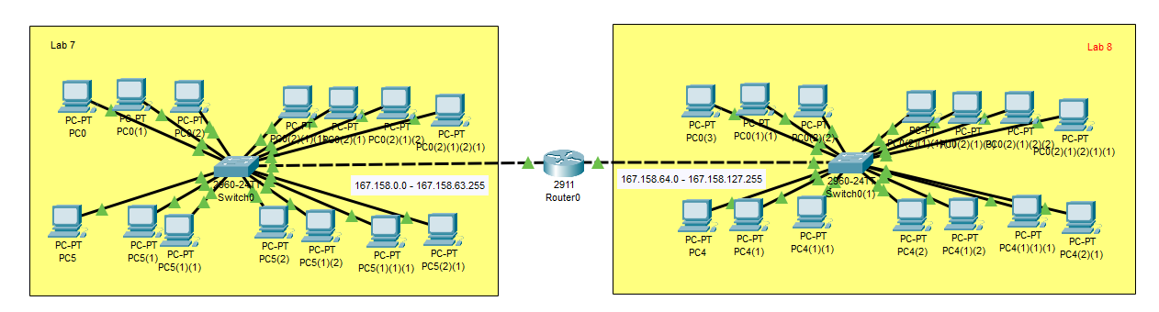

## Super-netting

Super-netting is the opposite of subnetting. It is the process of combining multiple smaller subnets into a larger network. Super-netting is often used when an organization wants to consolidate its networks or when an IP address block needs to be aggregated for more efficient routing, typically at a higher level in the internet routing table.

Super-netting uses CIDR to combine several networks into one larger network, represented by a single prefix.

### Example

If you have four subnets, each with a network like 192.168.1.0/24, 192.168.2.0/24, 192.168.3.0/24, and 192.168.4.0/24, you could super-net these networks into one larger network with a /22 prefix, which includes all the addresses in these smaller subnets.

**Original Networks**

* 192.168.1.0/24
* 192.168.2.0/24
* 192.168.3.0/24
* 192.168.4.0/24

**Super-netted Networks**

* 192.168.0.0/22

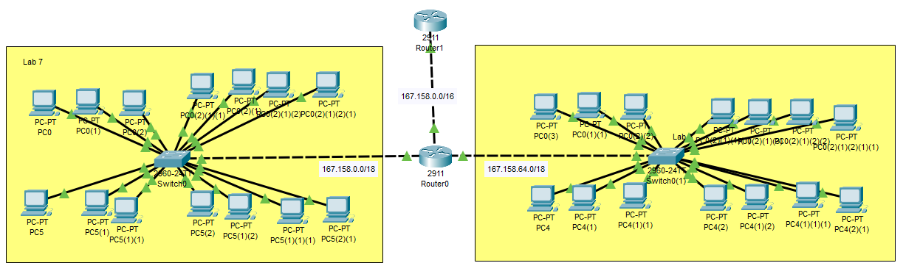

## Direct Comparison

|  |  |  |
| --- | --- | --- |
|  | **Sub-netting** | **Super-netting** |
| **Purpose** | Divides a large network into multiple smaller networks | Combines smaller networks into a larger network |
| **Network Size** | Results in smaller networks (more network bits are used) | Results in larger networks (less network bits are used) |
| **Usage** | Used for organizing local area networks | Used for aggregating addresses for routing efficiency |